Local organizations share value to residents in need during church fair BY JOHN MCKENNA Republican-American April 3, 2022
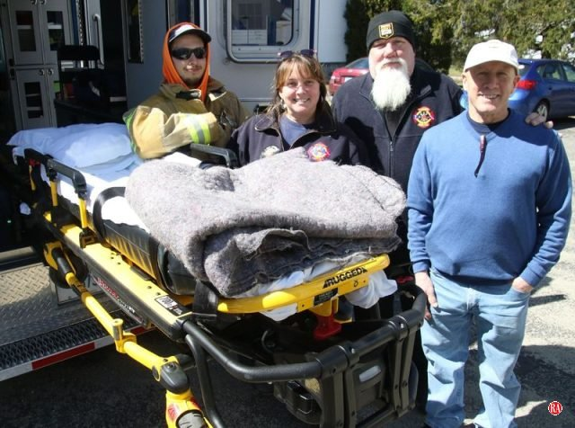
Goshen Fire Company volunteers, from left, Alex Miller, Barbara Balnis and Dave Parillo, and Goshen Fire Marshal Bob Diorio participate in a health and wellness fair sponsored by Goshen Community Care and Hospice on Saturday. John McKenna Republican-American
GOSHEN — Twenty local community organizations ranging from the new Sustainable Goshen to Friendly Hands Food Bank, Inc. in Torrington took advantage of an opportunity to promote themselves at Church of Christ Congregational on Saturday.
The church hosted an inaugural health and wellness fair organized by Goshen Community Care and Hospice to give the public a chance to see what services are available locally in the area, and learn about organizations that work to encourage physical and spiritual wellness.
“There are all kinds of wellness: physical, spiritual, earth wellness, fire safety among them,” said Erin Reilly, coordinator of Goshen Community Care and Hospice. “Most people don’t know what’s available to them at no cost or low cost, so here they can learn. I’m amazed by the number of organizations that wanted to be part of it.”
Michelle Brady, the director of nursing for Community Health and Wellness in Torrington, was one of the participants. She explained the organization’s mission of helping meet the health needs of the uninsured and undocumented, and individuals lacking transportation.
A crew from the Goshen Fire Company was on hand with an ambulance to demonstrate the use of a hydraulic lift stretcher and a specially-designed chair that can carry patients down stairs. Fire Marshal Bob Diorio provided tips on fire prevention and safety in the home.
Sustainable Goshen was established this year to take steps to make Goshen a more sustainable and vibrant town through environmental initiatives. The health and wellness fair over the weekend was its first chance to showcase itself to the public.
Sustainable Goshen members Joyce Mowrey and Judi Armstrong explained the organization’s recycling initiative that involves the collection of plastic household bags and wrap. The goal is to collect 50 pounds of plastic that would be used to build a new bench for a pollinator garden in town.
“We’re trying to help people understand what we’re doing and that Goshen has a lot to celebrate in the area of environmental conservation,” Mowrey said.
Karen Thomas, executive director of Friendly Hands Food Bank, said demand for food is growing weekly and their business is there to help.
“It’s a sad state we’re in, but we don’t want anyone to have to choose between paying their bills and putting food on the table,” she said.
Friendly Hands Food Bank is one of several organizations that benefit from the Goshen Green Garden, a food ministry of the Church of Christ Congregational that grows organic food at its garden in town and donates it to help feed the needy.
“We call it our Garden of Feedin’,” Goshen Green Garden member Lynn Fulkerson said. “We’ve been popular with the community and last year expanded with six more plots.”

